**INTRODUCTION**

* 1. **About The Project**

In the ever-evolving financial landscape, the ability to accurately predict loan approvals is crucial for lending institutions. Traditional methods of assessing creditworthiness, which often rely on manual processes and heuristic evaluations, are increasingly being supplemented by advanced data science techniques. The objective of this project is to develop a predictive model that can effectively determine the likelihood of loan approval based on various applicant characteristics and financial metrics.

* 1. **Problem Statement**

**Problem title:**

“LOAN APPROVAL PREDICTION”

**Problem Overview:**

The traditional loan approval process is often manual, leading to inefficiencies and potential inconsistencies in decision-making. This manual approach can introduce biases, affecting fairness and accuracy. Compounding this issue, loan application data is complex and multifaceted, involving various features such as applicant demographics, financial history, and loan specifics, which interact in intricate ways. Handling these complexities, including missing values and outliers, presents significant challenges. Developing a predictive model that can accurately forecast loan approval outcomes is crucial, as it must balance precision and recall while ensuring fairness. Additionally, the model must provide transparent and understandable predictions to stakeholders and be seamlessly integrated into existing loan processing systems to support real-time decision-making.

**1.3 Objectives of the Project**

1. **Data Collection and Preprocessing:**
   * Gather and clean historical loan application data, addressing missing values and outliers.
2. **Feature Selection and Engineering:**
   * Identify and select relevant features impacting loan approval decisions.
   * Engineer new features to enhance model performance.
3. **Model Development:**
   * Apply various machine learning algorithms to build a predictive model for loan approval outcomes.
4. **Model Evaluation:**
   * Assess model performance using metrics such as accuracy, precision, recall, and F1 score.
5. **Interpretability:**
   * Ensure the model’s predictions are interpretable and actionable for stakeholders.
6. **Deployment and Integration:**
   * Develop a framework for integrating the model into existing loan processing systems for real-time decision support.

**System Requirements and Specifications**

**2.1. Hardware Requirements:**

**Processor:**

Multi-core processor (e.g., Intel i5 or higher, AMD Ryzen 5 or higher) for efficient data processing and model training.

**Memory:**

Minimum 16 GB RAM to handle large datasets and complex computations.

**Storage:**

Minimum 500 GB SSD for fast data access and storage of datasets and model files.

Additional external storage or cloud storage options for large-scale data if needed.

**Graphics Processing Unit (GPU):**

Optional but recommended for faster model training, particularly with large neural networks (e.g., NVIDIA GTX 1080 or higher).

**2.2 Software Requirements:**

**Operating System:**

Windows 10 or later, macOS 10.14 or later, or a modern Linux distribution (e.g., Ubuntu 20.04 or later).

**Programming Languages:**

Python (preferred for its extensive libraries and support for data science and machine learning).

R (optional, if preferred for statistical analysis).

**Libraries and Frameworks:**

**Data Processing:** Pandas, NumPy, Scikit-learn

**Machine Learning:** Scikit-learn

**Data Visualization:** Matplotlib, Seaborn

**Integrated Development Environment (IDE):** Jupyter Notebook, PyCharm, or Visual Studio Code for coding and development.

**Network:** Reliable internet connection for data access, software updates, and collaboration.

**Security:** Implementation of secure authentication methods for accessing sensitive data.

Regular updates and patches for software to protect against vulnerabilities.

Data encryption in transit and at rest to ensure data privacy and security.

**IMPLEMENTATION**Top of Form

**3.1Function Method Description**

**1. Import Libraries and Load Data**

* **Libraries:** Imports essential libraries for data manipulation (pandas), numerical operations (numpy), and visualization (matplotlib, seaborn).
* **Data Loading:** Reads the dataset from a CSV file into a DataFrame named data and displays the first 5 rows to give an initial look at the data.

**2. Categorical Variables Identification and Encoding**

* **Categorical Variables Identification:** Identifies columns with datatype 'object', which typically represent categorical variables.
* **Initial Count of Categorical Variables:** Prints the number of categorical columns in the dataset.
* **Label Encoding:** Uses LabelEncoder from sklearn to convert categorical variables into numerical format, which is necessary for machine learning algorithms.
* **Rechecking Categorical Variables:** After encoding, it rechecks and prints the number of categorical variables to confirm all have been encoded.

**3. Correlation Matrix Visualization**

* **Correlation Matrix:** Computes and visualizes the correlation matrix of the numerical features using a heatmap. This helps identify relationships between features and their potential impact on the target variable.

**4. Handling Missing Values**

* **Filling Missing Values:** Replaces missing values in each column with the mean of that column. This is a common technique to handle missing data.
* **Check for Missing Values:** Verifies if there are any remaining missing values in the dataset after imputation.

**5. Train-Test Split**

* **Feature and Target Separation:** Separates the dataset into features (X) and the target variable (Y). The target variable here is Loan_Status.
* **Train-Test Split:** Splits the data into training and testing sets using train_test_split. The test size is set to 40% of the dataset, and random_state=1 ensures reproducibility of the split.
* **Shape of Data:** Outputs the shapes of training and testing datasets to verify the split.

**3.2PSEUDO CODE**

import pandas as pd

import numpy as np

import matplotlib.pyplot as plt

import seaborn as sns

data = pd.read_csv("LoanApprovalPrediction.csv")

data.head(5)

obj = (data.dtypes == 'object')

print("Categorical variables:",len(list(obj[obj].index)))

# Import label encoder

from sklearn import preprocessing

# label_encoder object knows how

# to understand word labels.

label_encoder = preprocessing.LabelEncoder()

obj = (data.dtypes == 'object')

for col in list(obj[obj].index):

data[col] = label_encoder.fit_transform(data[col])

# To find the number of columns with

# datatype==object

obj = (data.dtypes == 'object')

print("Categorical variables:",len(list(obj[obj].index)))

plt.figure(figsize=(12,6))

sns.heatmap(data.corr(),cmap='BrBG',fmt='.2f',linewidths=2,

annot=True)

plt.figure(figsize=(12,6))

sns.heatmap(data.corr(),cmap='BrBG',fmt='.2f', linewidths=2,annot=True)

for col in data.columns:

data[col] = data[col].fillna(data[col].mean())

data.isna().sum()

from sklearn.model_selection import train_test_split

X = data.drop(['Loan_Status'],axis=1)

Y = data['Loan_Status']

X.shape,Y.shape X_train, X_test, Y_train, Y_test =

train_test_split(X, Y, test_size=0.4,random_state=1)

X_train.shape, X_test.shape, Y_train.shape, Y_test.shape

**3.3RESULT (Screenshot of the output)**

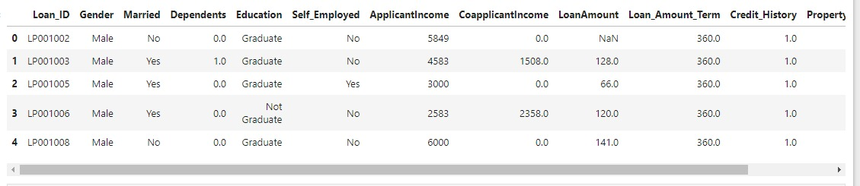

Categorical variables: 7

Categorical variables: 0

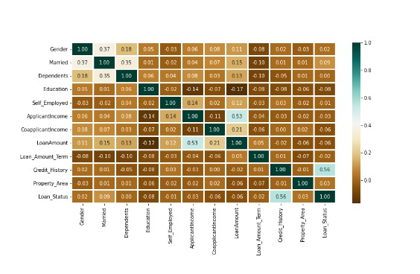

Bottom of Form

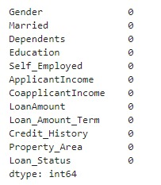

((358, 11), (240, 11), (358,), (240,))

**CONCLUSION**

In conclusion, the preprocessing steps undertaken have established a solid foundation for developing a predictive model for loan approval. The initial inspection of the dataset revealed its structure and content, while the conversion of categorical variables into numerical format enabled the application of machine learning algorithms. The correlation analysis provided valuable insights into feature relationships, guiding feature selection and model development. By addressing missing values through mean imputation, we ensured the dataset’s completeness and readiness for modeling. The subsequent train-test split, reserving 40% of the data for testing, sets the stage for robust model evaluation. These preparatory actions have effectively set up the framework for building, evaluating, and deploying a model capable of enhancing loan approval processes, paving the way for improved decision-making and operational efficiency.

**Top of Form**

**Bottom of Form**